A Kind of Reconfigurable Memristor Circuit

Deyong Tan1, Xun Fu2, Juhong Peng2 and Weiming Yang2*

1 School of xxx, xxx University, Wuhan, China

xxxx@16.com

**Abstract.** In order to implement multi logical functions with less hardware overhead, a kind of voltage controlled reconfigurable memristive logical circuit which can realize the entire logical family was presented in this paper. The circuit,

**Keyword:** 4-6 keywords.

1. Introduction

Memristor, predicted by Chua in 1971, was regarded as the fourth circuit element S compatibility.

Currently, more and more research papers on memristive logical circuits design were reported. For example, a multi-inputs stateful OR circuit with two memristors in one step to realize OR logic [3], the architecture of 4M1M realizes AND, OR, NOT logical well-known nanoelectronic structure. There are some reports about the memristive crossbar, such as 1T1R [6], 4M1M [4], IMP logic gate in crossbar [7], and functional Complete Stateful Boolean Logic in Memristive Crossbar [8].

.

1. Section 1
   1. Subsection 1

The theory of a current-controlled time-invariant memristive system can be described as:

 (1)

If , the resistance of memristor is Ron, while, the resistor is Roff.

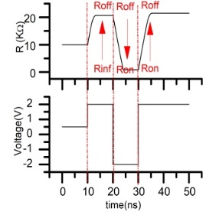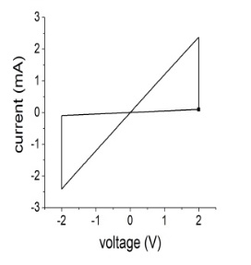

(a)xxx (b)xxxx

**Fig. 1.** xxxxx.

**Table 1**. xxxxx.

|  |  |  |  |  |
| --- | --- | --- | --- | --- |
| a | b | c | d | e |
| A | B | 0 | 0 | f |

1. Conclusion

xxxxxx

Acknowledgement

Xxxxx

References

1. Chua, L.: Memristor--the missing circuit element. IEEE Transactions on Circuit Theory 18(5), 507-519(1971)
2. Strukov, D. B., et al.: The missing memristor found. Nature 453(7191), 80-83(2008)
3. Chen, Q., Wang, X. P., Wan, H. B, Yang, R., Zheng, J.: A circuit design for muliti-inputs stateful OR gate. Physics Letters A 380(38), 3081-3085(2016)